**Program 29 : Write a program to find Fibonacci series.**

#include<stdio.h>

void main()

{

int first=0,second=1,next,c;

printf("enter the limit");

int n;

scanf("%d",&n);

for(c=0;c<n;c++)

{

if(c<=1)

next=c;

else

{

next=first+second;

first=second;

second=next;

}

printf("%d\n",next);

}

}

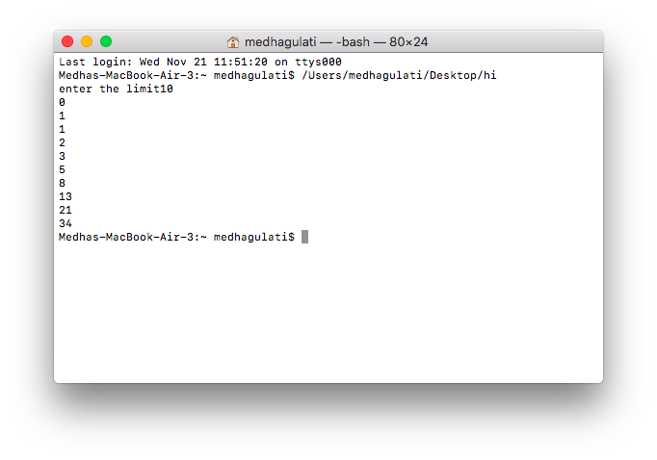

**Program 30 : Word size of the computer refers to the number of bytes that can be stored in a single memory location. Write a program to find word size of the computer**

#include <stdio.h>

#include <limits.h>

int main(void)

{

printf("\n Word size of the computer = %d\n", sizeof(void *) * CHAR_BIT);

return 0;

}

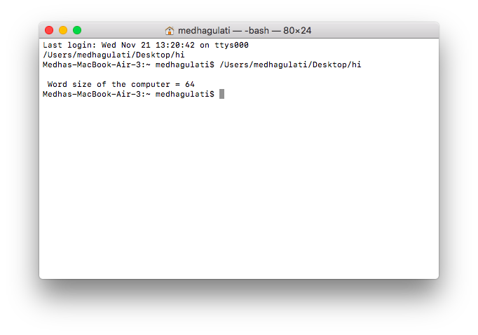

**Program 31 . Write a program to illustrate the working of pointer to pointer.**

#include<stdio.h>

void main()

{

int a=8,*p,*p1;

p=&a;

p1=p;

printf("\n Value of variable=%d",a);

printf("\n Value of pointer=%d",*p);

printf("\n Vlaue of pointer to pointer=%d",*p1);

}

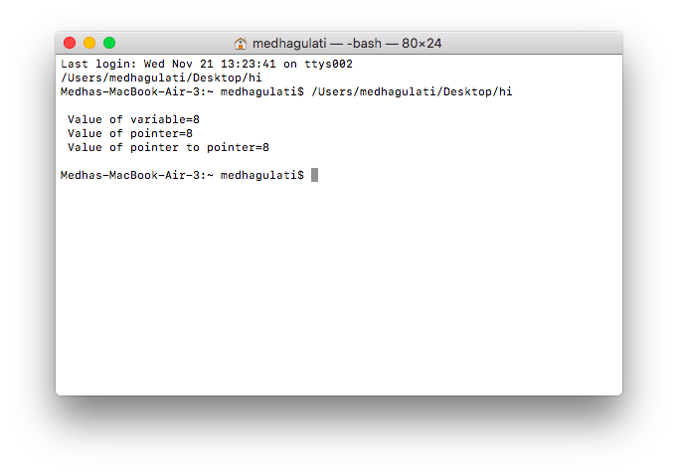

**Program 32 : Write programs to illustrate pointer arithmetic for different types of pointers.**

#include<stdio.h>

int main()

{

int i=12, *ip=&i;

double d = 2.3, *dp = &d;

char ch = 'a', *cp = &ch;

printf("Value of ip = %d\n",ip);

printf("Value of dp = %d\n",dp);

printf("Value of cp = %d\n",cp);

printf("Value of ip = %d\n",ip + 1);

printf("Value of dp = %d\n",dp + 1);

printf("Value of cp = %d\n",cp + 1);

printf("Value of ip = %d\n",ip + 2);

printf("Value of dp = %d\n",dp + 2);

printf("Value of cp = %d\n",cp + 2);

return 0;

}

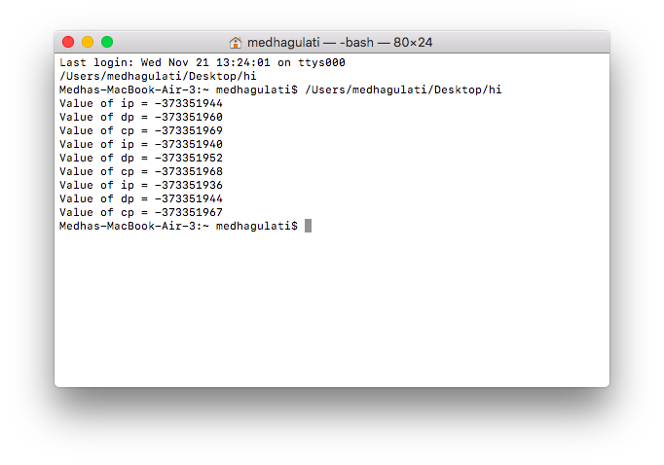

**Program 33 : Write a program to find size of various types of pointers (int, float, char)? What are the factors on which size depends?**

#include <stdio.h>

int main()

{

    printf("\nsize of char pointer: %d"     ,sizeof(char*));

    printf("\nsize of int pointer: %d"      ,sizeof(int*));

    printf("\nsize of float pointer: %d"    ,sizeof(float*));

    printf("\nsize of long int pointer: %d" ,sizeof(long int*));

    printf("\nsize of double pointer: %d\n" ,sizeof(double*));

    return 0;

}

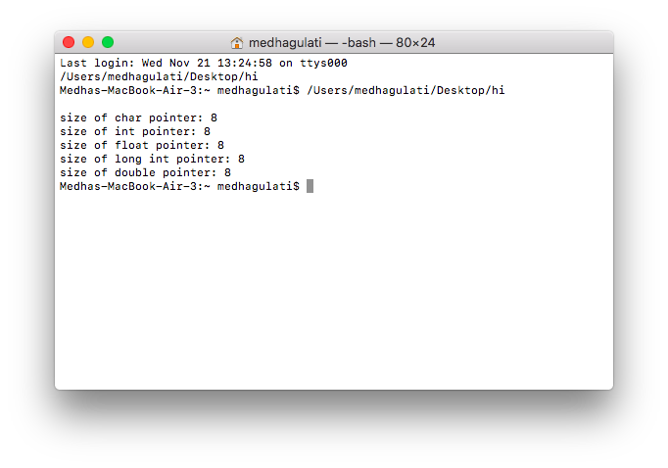

**Program 34 : Write a program to input a string and display the same as output.**

#include <stdio.h>

int main()

{

    char name[30];

    printf("Enter name: ");

    gets(name);     // read string

    printf("Name: ");

    puts(name);    // display string

    return 0;

}

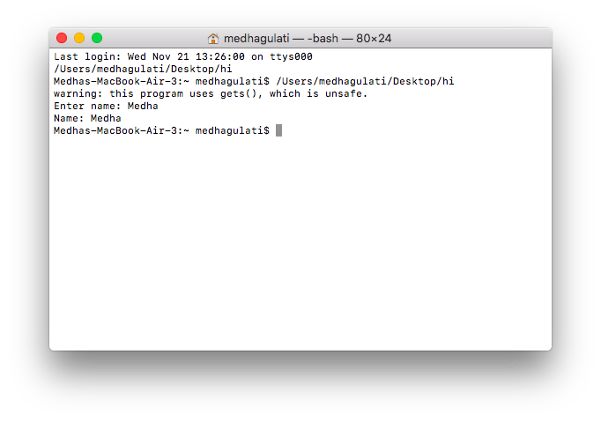

**Program 35 : Write a program to find the length of string without using library functions.**

#include<stdio.h>

void main()

{

char s[50];

int i=0;

printf("\n enter the string");

scanf("%s",s);

for(i=0;s[i]!='\0';i++);

printf("\n Length of string=%d",i);

}

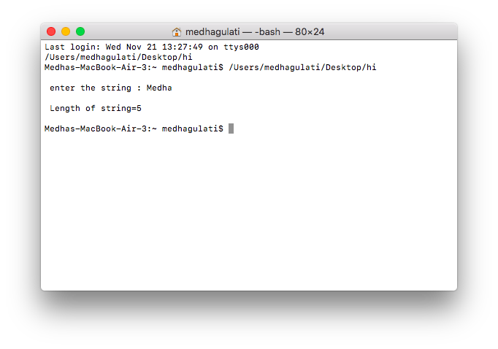

**Program 36 : Write a program to compare two strings without using library functions.**

#include<stdio.h>

void main()

{

char s1[10],s2[10];

int i,flag=0;

printf("\n Enter the string : ");

scanf("%s",s1);

printf("\n Enter the second string : ");

scanf("%s",s2);

for(i=0;s1[i]!='\0';i++) {

if(s1[i]==s2[i])

flag=flag+1;

}

if(flag==i)

printf("\n Strings are equal");

else

printf("\n Strings are not equal");

}

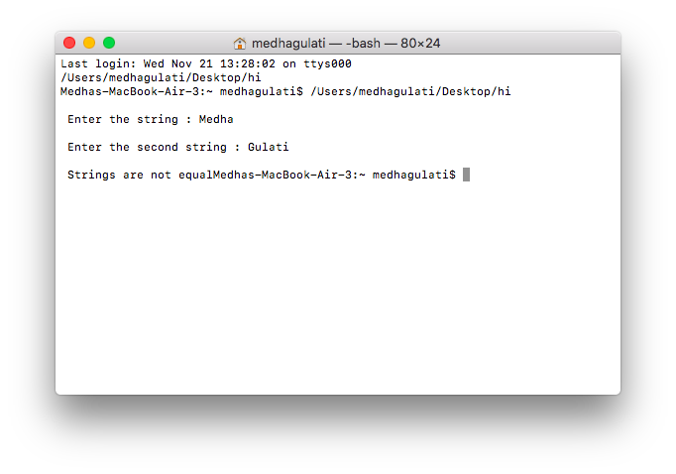

**Program 37 : Write a program to copy a string without using library functions.**

#include<stdio.h>

int main()

{

char s1[10],s2[10];

int i;

printf("\n enter the string");

scanf("%s",s1);

for(i=0;s1[i]!='\0';i++)

{

s2[i]=s1[i];

}

s2[i]='\0';

printf("\n Copied String = %s",s2);

return 0 ;

}

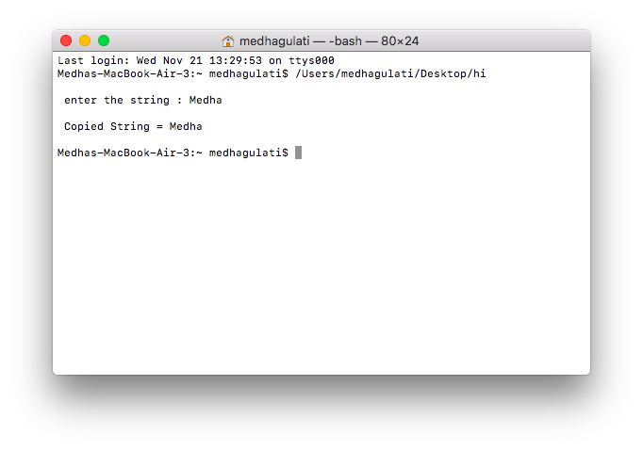

**Program 38 : Write a program to reverse a string without using library functions.**

#include<stdio.h>

void main()

{

char s1[10],s2[10];

int i,l,j;

printf("\n Enter the string : ");

scanf("%s",s1);

for(i=0;s1[i]!='\0';i++);

j=0;

for(l=i-1;l>=0;l--)

{

s2[j]=s1[l];

j++;

}

s2[j]='\0';

printf("\n Reversed string = %s",s2);

}

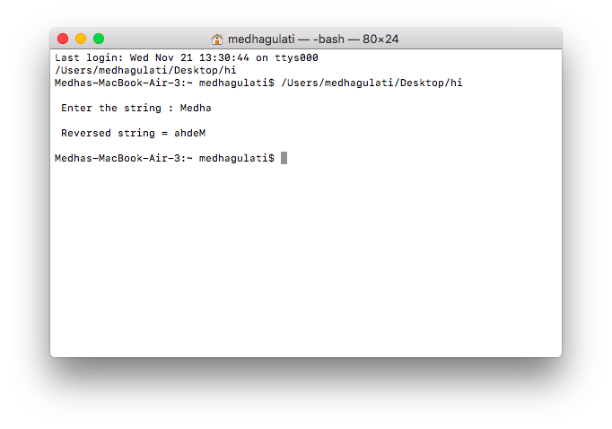

**Program 39 . Write a program to concatenate two strings without using library functions.**

#include<stdio.h>

void main()

{

char s1[10],s2[10],s3[20];

int i,j,l;

printf("\n Enter the string1 : ");

scanf("%s",s1);

printf("\n enter the string2");

scanf("%s",s2);

for(i=0;s1[i]!='\0';i++)

{

s3[i]=s1[i];

}

l=i;

for(i=0;s2[i]!='\0';i++)

{

s3[l]=s2[i];

l++;

}

s3[l]='\0';

printf("\n Concatenate String = %s",s3);

}

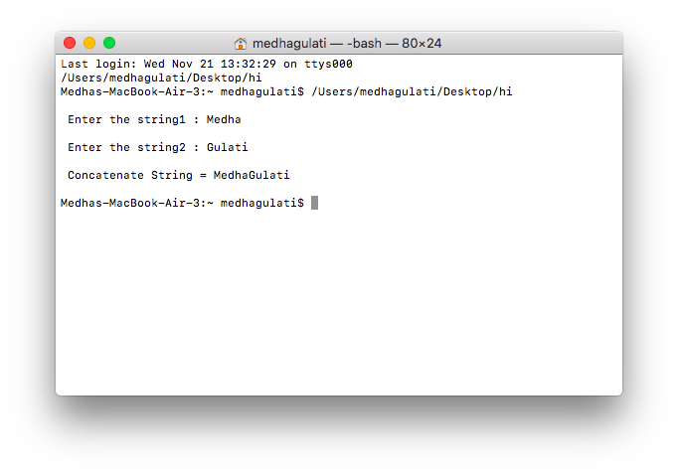

**Program 40 : Write a program to illustrate scope,visibility and lifetime of various storage classes.**

1. **Auto Class**

#include<stdio.h>

void f1()

{

auto int i=2;

printf("\n Value in f1 = %d",i);

}

void f2()

{

auto int i=3;

printf("\n Value in f2 = %d",i);

}

void main()

{

auto int i=1;

f1();

f2();

printf("\n Value in main = %d",i);

}

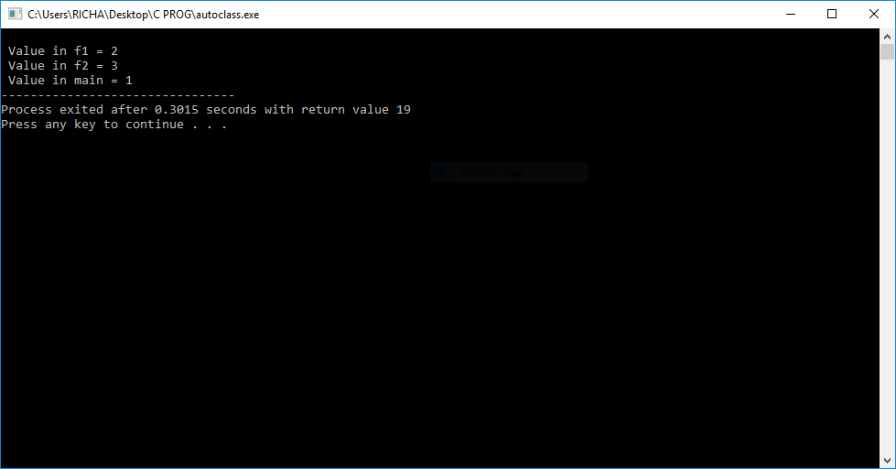

**B)Static Class**

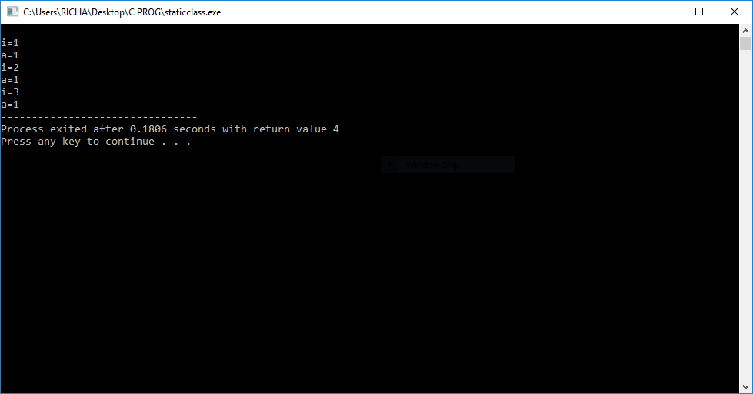

**Program 41 : Write a program to find the area of circle using PI as a macro.**

#include<stdio.h>

#define pi 3.1416

int main()

{

float area, radius;

printf("enter the radius of circle \n"); scanf("%f",&radius); area=pi*radius*radius;

printf("\n the area of the circle is = %f" , area);

return 0;

}

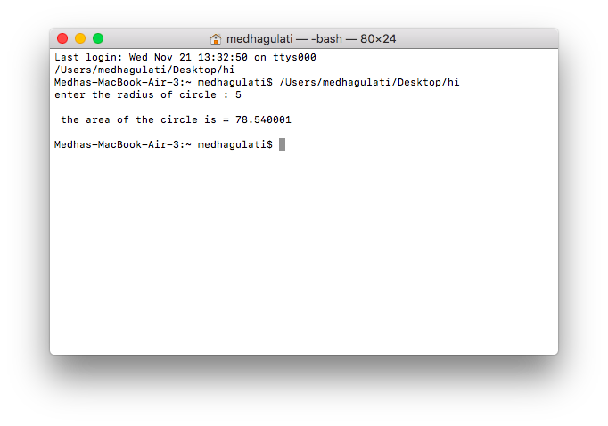

**Program 42 : Illustrate pointer to structure.**

#include<stdio.h>

struct book

{

char title[50];

int page;

float cost;

};

void main()

{

int i,j;

struct book b,*p;

p=&b;

printf("\n enter the book title : ");

fgets((p+i)->title,50,stdin);

fflush(stdin);

printf("\n enter the page : ");

scanf("%d",&(p+i)->page);

fflush(stdin);

printf("\n enter the cost : ");

scanf("%f",&(p+i)->cost);

fflush(stdin);

printf("\n enter the book title = %s",(p+i)->title); fflush(stdin);

printf("\n enter the page = %d",(p+i)->page); fflush(stdin);

printf("\n enter the cost = %.2f\n",(p+i)->cost);

}

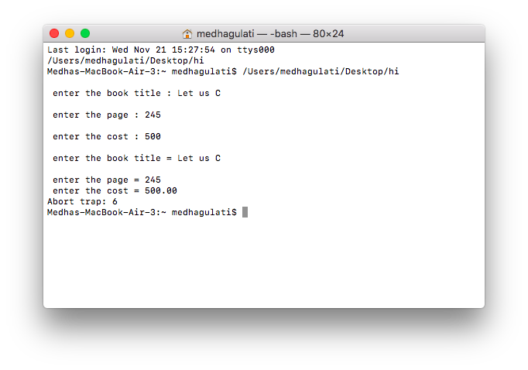

**Program 43 : Write a function that takes two end points of line segment as input and returns its slope and mid point.**

#include<stdio.h>

#include<conio.h>

void main()

{

    float x1,x2,y1,y2,slope,midX,midY;

    clrscr();

    printf(" Enter the X Coordinate of Endpoint 1: ");

    scanf("%f",&x1);

    printf(" Enter the Y Coordinate of Endpoint 1: ");

    scanf("%f",&y1);

    printf(" Enter the X Coordinate of Endpoint 2: ");

    scanf("%f",&x2);

    printf(" Enter the Y Coordinate of Endpoint 2: ");

    scanf("%f",&y2);

    printf(" The Endpoints of a Line are : (%.2f,%.2f) and (%.2f,%.2f)",x1,y1,x2,y2);

    slope=(y2-y1)/(x2-x1);

    midX=(x1+x2)/2;

    midY=(y1+y2)/2;

    printf(" Slope : %.2f",slope);

    printf(" Midpoint : (%.2f,%.2f)",midX,midY);

    getch();

}

**Program 44 : Write a program to read a file as input and count the number of characters, words and lines.**

#include<stdio.h>

void main()

{

FILE *fp;

int l=0,w=0,c=0;

charstr,fname[50];

printf("\n enter filename");

scanf("%s",fname);

printf("\n write content in file");

fp=fopen(fname,"w");

while((str=getchar())!=EOF)

putc(str,fp);

fclose(fp);

fp=fopen(fname,"r");

while((str=fgetc(fp))!=EOF)

{

if(str=='\n')

{

l++;

w++;

}

else if(str==' ')

w++;

else

c++;

}

fclose(fp);

printf("\n Lines=%d\nWords=%d\nCharacters=%d",l,w,c);

}

**Program 45 : Write a program to copy a source text file into a target text file.**

#include <stdio.h>

#include <stdlib.h>

main()

{

   char ch, source_file[20], target_file[20];

   FILE *source, *target;

   printf("Enter name of file to copy\n");

   gets(source_file);

   source = fopen(source_file, "r");

   if( source == NULL )

   {

      printf("Press any key to exit...\n");

      exit(EXIT_FAILURE);

   }

   printf("Enter name of target file\n");

   gets(target_file);

   target = fopen(target_file, "w");

   if( target == NULL )

   {

      fclose(source);

      printf("Press any key to exit...\n");

      exit(EXIT_FAILURE);

   }

   while( ( ch = fgetc(source) ) != EOF )

      fputc(ch, target);

   printf("File copied successfully.\n");

   fclose(source);

   fclose(target);

   return 0;

}

**Program 46 : Write a program to read and write the file using following commands**

**a.)fgetc() and fputc()**

#include<stdio.h>

void main()

{

FILE *fp;

intch;

charstr,fname[50];

printf("\n enter filename");

scanf("%s",fname);

printf("\n write content in file");

fp=fopen(fname,"w");

while((str=getchar())!=EOF)

fputc(str,fp);

fclose(fp);

printf("\n reading contents");

fp=fopen(fname,"r");

fflush(stdin);

while((str=fgetc(fp))!=EOF)

{

putchar(str);

}

fclose(fp);

}

**Output:**

w

**b.)fprintf() and fscanf()**

#include<stdio.h>

#include<curses.h>

void main()

{

FILE *fp;

charstr[50],fname[10];

printf("\n enter the filename");

scanf("%s",fname);

fp=fopen(fname,"w");

printf("\n enter the contents u wnat to store in file"); while(fgets(str,50,stdin)!=NULL)

{

fgets(str,50,stdin);

fprintf(fp,"%s",str);

}

fclose(fp);

fp=fopen(fname,"r");

printf("\n reading contents of file"); while(!feof(fp))

{

fscanf(fp,"%s",str);

printf("%s",str);

}

fclose(fp);

}

**Output:**

**c.)fread() and fwrite()**

#include<stdio.h>

#include<string.h>

void main()

{

FILE *fp;

intch;

charstr[100],fname[10];

printf("\n enter the filename");

scanf("%s",fname);

printf("\n enter contents of file");

fp=fopen(fname,"wb");

fflush(stdin);

while(scanf("%s",str)!=EOF)

fwrite(str,strlen(str),1,fp);

fclose(fp);

printf("\n reading contents of file\n");

fp=fopen(fname,"rb");

fflush(stdin);

while(fread(&str,sizeof(char),1,fp))

printf("%s",str);

fclose(fp);

}

**Output:**

**Program 47 : Given it was Monday on 1st Jan 1990 . Write a program to find what is the day on 1st Jan of the given year.**

#include <stdio.h>

int main(void)

{

int yr,diff,lpyrdays,normaldays,res;

printf("\nEnter a year whose day of 1st Jan you want to know : ");

scanf("%d",&yr);

yr = (yr - 1) ;

lpyrdays = (yr/4) + (yr / 400) - (yr / 100 );

normaldays = (yr* 365 )+ 1 + lpyrdays ;

res = normaldays % 7;

if(res==0)

printf("\nSunday");

if(res==1)

printf("Monday");

if(res==2)

printf("Tuesday");

if(res==3)

printf("Wednesday");

if(res==4)

printf("Thursday");

if(res==5)

printf("Friday");

if(res==6)

printf("Saturday");

return 0;

}

**Program 48 : Write a program to input a number and print its digit in words.**

#include <stdio.h>

int main()

{

    int n, num = 0;

    /* Input number from user */

    printf("Enter any number to print in words: ");

    scanf("%d", &n);

    /* Store reverse of n in num */

    while(n != 0)

    {

        num = (num * 10) + (n % 10);

        n /= 10;

    }

    /*

     * Extract last digit of number and print corresponding digit in words

     * till num becomes 0

     */

    while(num != 0)

    {

        switch(num % 10)

        {

            case 0:

                printf("Zero ");

                break;

            case 1:

                printf("One ");

                break;

            case 2:

                printf("Two ");

                break;

            case 3:

                printf("Three ");

                break;

            case 4:

                printf("Four ");

                break;

            case 5:

                printf("Five ");

                break;

            case 6:

                printf("Six ");

                break;

            case 7:

                printf("Seven ");

                break;

            case 8:

                printf("Eight ");

                break;

            case 9:

                printf("Nine ");

                break;

        }

        num = num / 10;

    }

    return 0;

}

**Program 49 : Generate the divisors of a given number.**

#include<stdio.h>

#include<conio.h>

void main()

{

int i,n;

clrscr();  //to clear the screen

printf(“Enter any number:”);

scanf(“%d”,&n);

printf(“nDivisors of %d are”,n);

for(i=1;i<n/2;++i)

if(n%i==0)

printf(” %d”,i);

getch();  //to stop the screen

}

**Program 50 : Find LCM and GCD of a given number.**

#include <stdio.h>

int main() {

  int a, b, x, y, t, gcd, lcm;

  printf("Enter two integers\n");

  scanf("%d%d", &x, &y);

  a = x;

  b = y;

  while (b != 0) {

    t = b;

    b = a % b;

    a = t;

  }

  gcd = a;

  lcm = (x*y)/gcd;

  printf("Greatest common divisor of %d and %d = %d\n", x, y, gcd);

  printf("Least common multiple of %d and %d = %d\n", x, y, lcm);

  return 0;

}

**Program 51 : Check whether square root of a given number is prime or not.**

#include <stdio.h>

#include<math.h>

int main()

{

    int n, i, flag = 0,sq;

    printf("Enter a positive integer : ");

    scanf("%d", &n);

    sq = sqrt(n);

    printf("\nSquare root of the no is : %d\n",sq);

    for(i = 2; i <= sq/2; ++i)

    {

        // condition for nonprime number

        if(sq%i == 0)

        {

            flag = 1;

            break;

        }

    }

    if (sq == 1)

    {

      printf("1 is neither a prime nor a composite number.\n");

    }

    else

    {

        if (flag == 0)

          printf("%d is a prime number.\n", sq);

        else

          printf("%d is not a prime number.\n", sq);

    }

    return 0;

}

**Program 52 : Add the number of days in a given date.**

**Program 53 : Count number of occurance of a given number in a given integer array**

int first(int arr[], int low, int high, int x, int n)

{

  if(high >= low)

  {

    int mid = (low + high)/2;  /*low + (high - low)/2;*/

    if( ( mid == 0 || x > arr[mid-1]) && arr[mid] == x)

      return mid;

    else if(x > arr[mid])

      return first(arr, (mid + 1), high, x, n);

    else

      return first(arr, low, (mid -1), x, n);

  }

  return -1;

}

/* if x is present in arr[] then returns the

   index of LAST occurrence of x in arr[0..n-1],

   otherwise returns -1 */

int last(int arr[], int low, int high, int x, int n)

{

  if (high >= low)

  {

    int mid = (low + high)/2;  /*low + (high - low)/2;*/

    if( ( mid == n-1 || x < arr[mid+1]) && arr[mid] == x )

      return mid;

    else if(x < arr[mid])

      return last(arr, low, (mid -1), x, n);

    else

      return last(arr, (mid + 1), high, x, n);

  }

  return -1;

}

/* if x is present in arr[] then returns the count

   of occurrences of x, otherwise returns -1. */

int count(int arr[], int x, int n)

{

  int i; // index of first occurrence of x in arr[0..n-1]

  int j; // index of last occurrence of x in arr[0..n-1]

  /* get the index of first occurrence of x */

  i = first(arr, 0, n-1, x, n);

  /* If x doesn't exist in arr[] then return -1 */

  if(i == -1)

    return i;

  /* Else get the index of last occurrence of x.

     Note that we are only looking in the subarray

     after first occurrence */

  j = last(arr, i, n-1, x, n);

  /* return count */

  return j-i+1;

}

/* driver program to test above functions */

int main()

{

  int arr[] = {1, 2, 2, 3, 3, 3, 3};

  int x =  3;  // Element to be counted in arr[]

  int n = sizeof(arr)/sizeof(arr[0]);

  int c = count(arr, x, n);

  printf(" %d occurs %d times ", x, c);

  getchar();

  return 0;

}

**Program 54 : Find the age of a person by given date of birth.**

#include <stdio.h>

#include <stdlib.h>

// function to calculate current age

void findAge(int current_date, int current_month,

             int current_year, int birth_date,

             int birth_month, int birth_year)

{

    // days of every month

    int month[] = { 31, 28, 31, 30, 31, 30, 31,

                          31, 30, 31, 30, 31 };

    // if birth date is greater then current birth

    // month then do not count this month and add 30

    // to the date so as to subtract the date and

    // get the remaining days

    if (birth_date > current_date) {

        current_date = current_date + month[birth_month - 1];

        current_month = current_month - 1;

    }

    // if birth month exceeds current month, then do

    // not count this year and add 12 to the month so

    // that we can subtract and find out the difference

    if (birth_month > current_month) {

        current_year = current_year - 1;

        current_month = current_month + 12;

    }

    // calculate date, month, year

    int calculated_date = current_date - birth_date;

    int calculated_month = current_month - birth_month;

    int calculated_year = current_year - birth_year;

    // print the present age

    printf("Present Age\nYears: %d  Months: %d  Days:"

           " %d\n", calculated_year, calculated_month,

                                      calculated_date);

}

// driver code to check the above function

int main()

{

    // current dd// mm/yyyy

    int current_date = 7;

    int current_month = 12;

    int current_year = 2017;

    // birth dd// mm// yyyy

    int birth_date = 16;

    int birth_month = 12;

    int birth_year = 2009;

    // function call to print age

    findAge(current_date, current_month, current_year,

            birth_date, birth_month, birth_year);

    return 0;

}

**Program 55 : Sum of the series ,when x is given.**

**1 + x^2/1! + x^4/2! + … + x^2n/n!**

#include<stdio.h>

#include<math.h>

int fact(int n)

{

    if(n==0||n==1)

        return 1;

    else

        return n*fact(n-1);

}

int main()

{

    int sum=1,x,n,num,deno,term;

    printf("\nEnter no of terms in the series : ");

    scanf("%d",&n);

    printf("\nEnter x : ");

    scanf("%d",&x);

    for(int i=1;i<=n;i++)

    {

        num = pow(x,i);

        deno = fact(i);

        term = num/deno;

        sum = sum + term;

    }

    printf("\nSum of the series : %d",sum);

    return 0;

}

**Program 56 : Find out the difference between 2 dates in terms of number of days.**